Practical No:02

**Aim:** Screen Resolution, Networking, Time Settings.

1. Screen Resolution: Ascertain the current screen resolution for your desktop.

**Go to setting and click on ‘Displays’ and under resolution choose the one that suits you.**

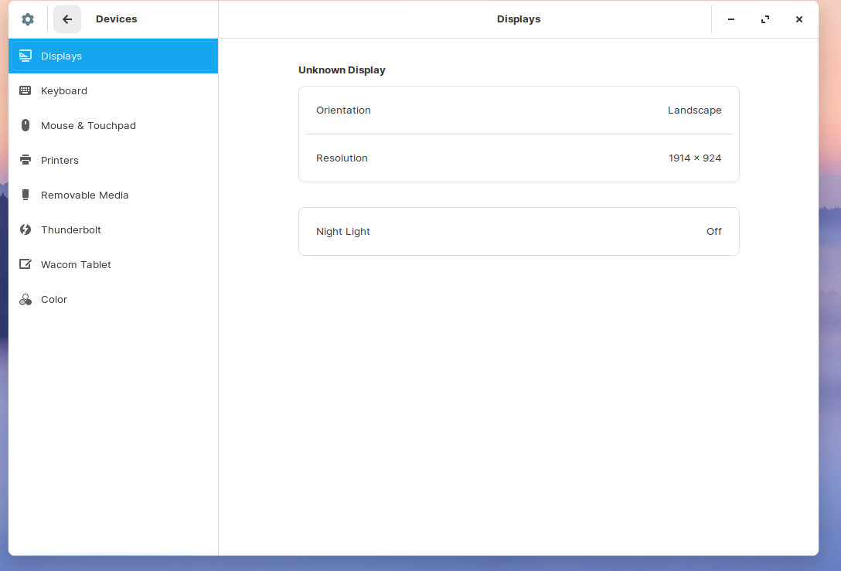

**After changing the resolution** 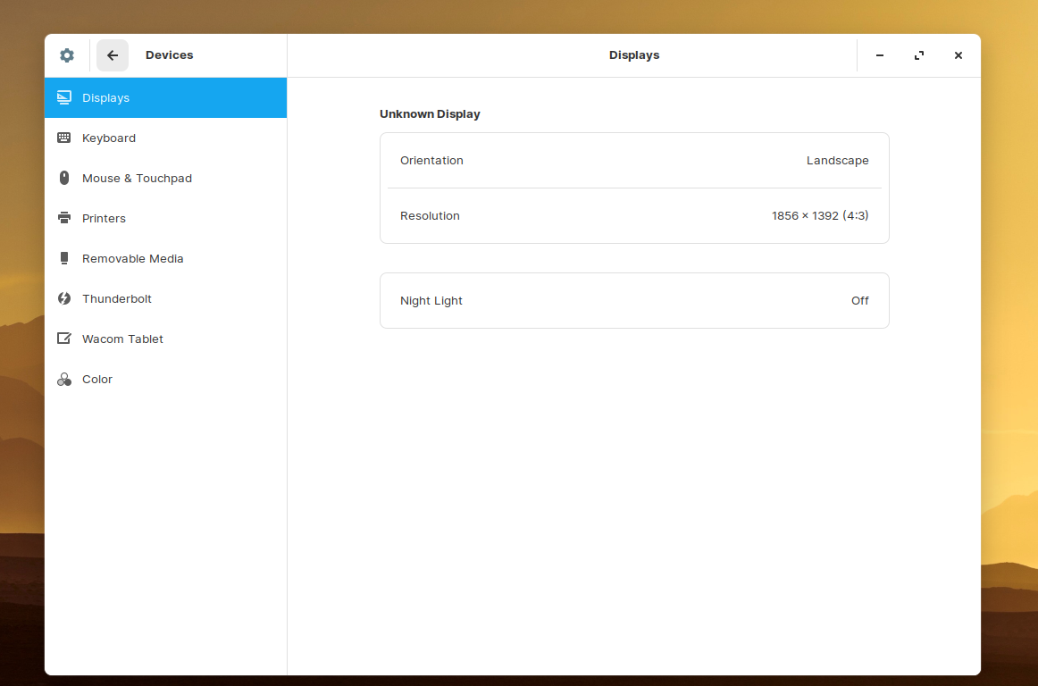

b) Networking: Get the current networking configuration for your desktop.

Are you on a wired or a wireless connection? What wireless connections are available, if any?

**Using GUI**

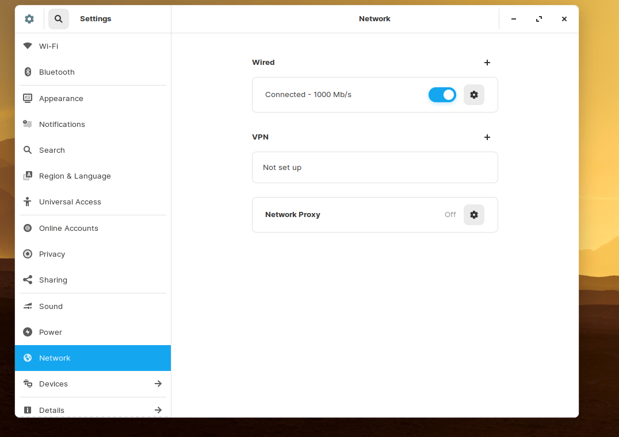

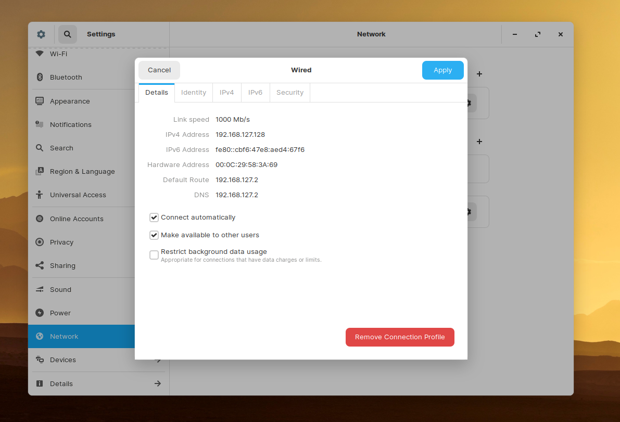

**Using CMD**

**Type ifconfig command, if the command is not found you can install with by using command ‘sudo apt install net -tools’**

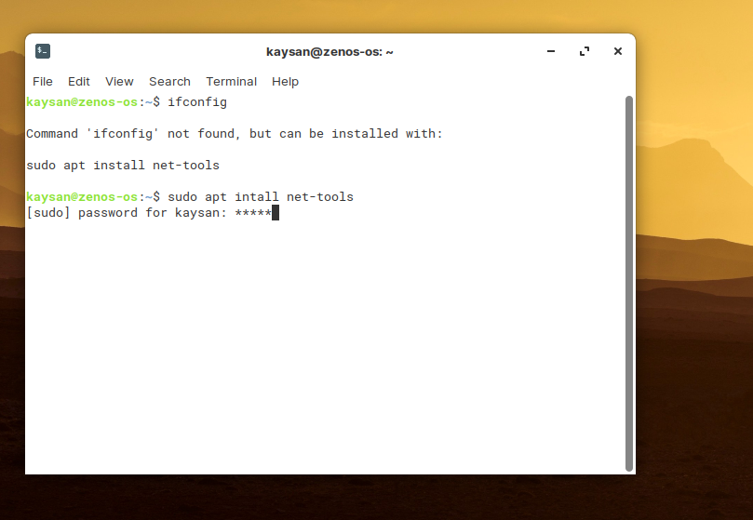

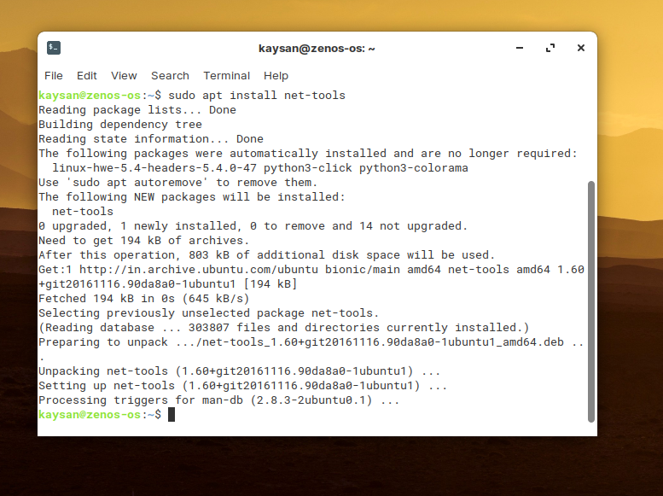

**After Using ifconfig**

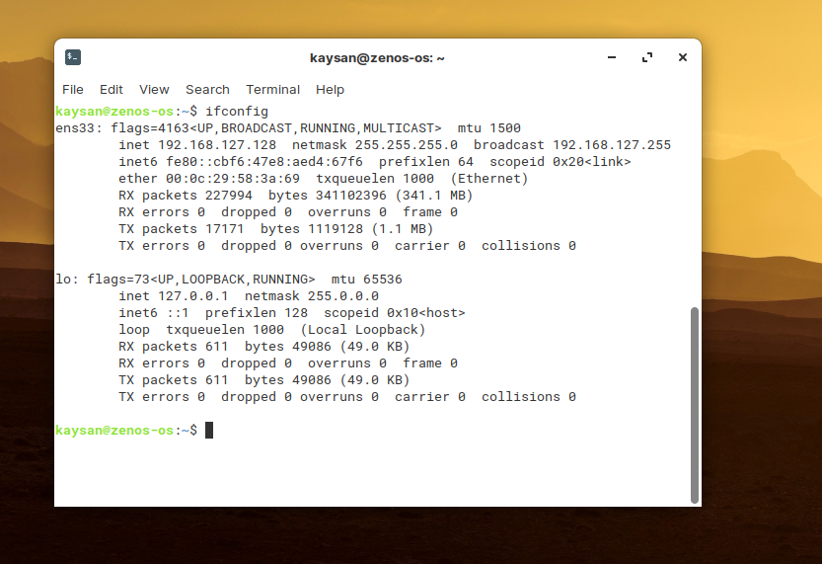

c) Time settings: Change the time zone of your system. After noting the time change, change the time zone back to your local time zone.

**Go to settings and click on ‘Date & Time’**

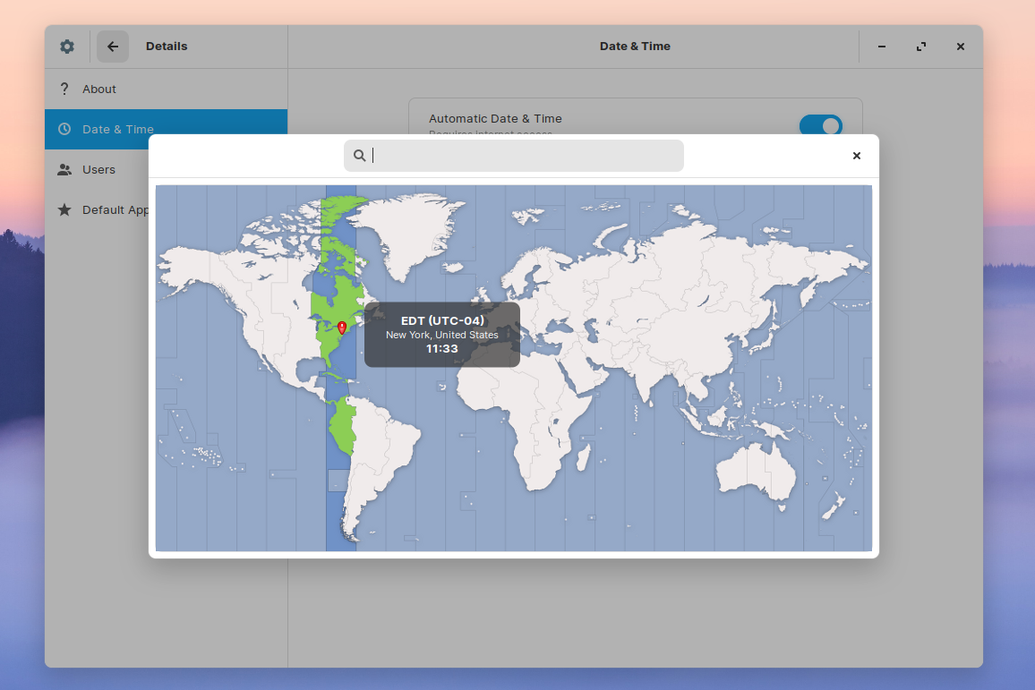

**After changing time zone**

